**~~SATYA-VITA~~**

**~~GROWERS OF FIVE VARIETIES OF PERFUMED ROSES~~**

~~Damascena, Centifoglia, Rosa Rugosa, Kazanlik, Queen Bourbon~~

**~~www.satya-vita.~~net :** Dolceacqua

**~~Recipes using fresh or dried petals~~**

~~Use your own garden roses or contact me for some, on : 0039-3468396697~~

~~sofia@satya-vita.net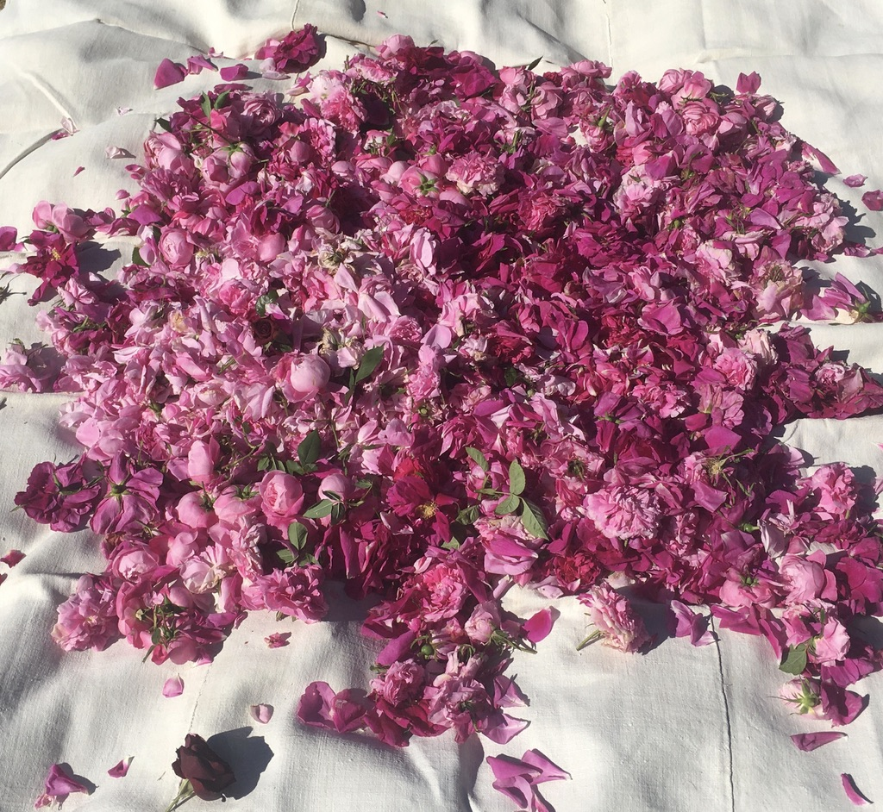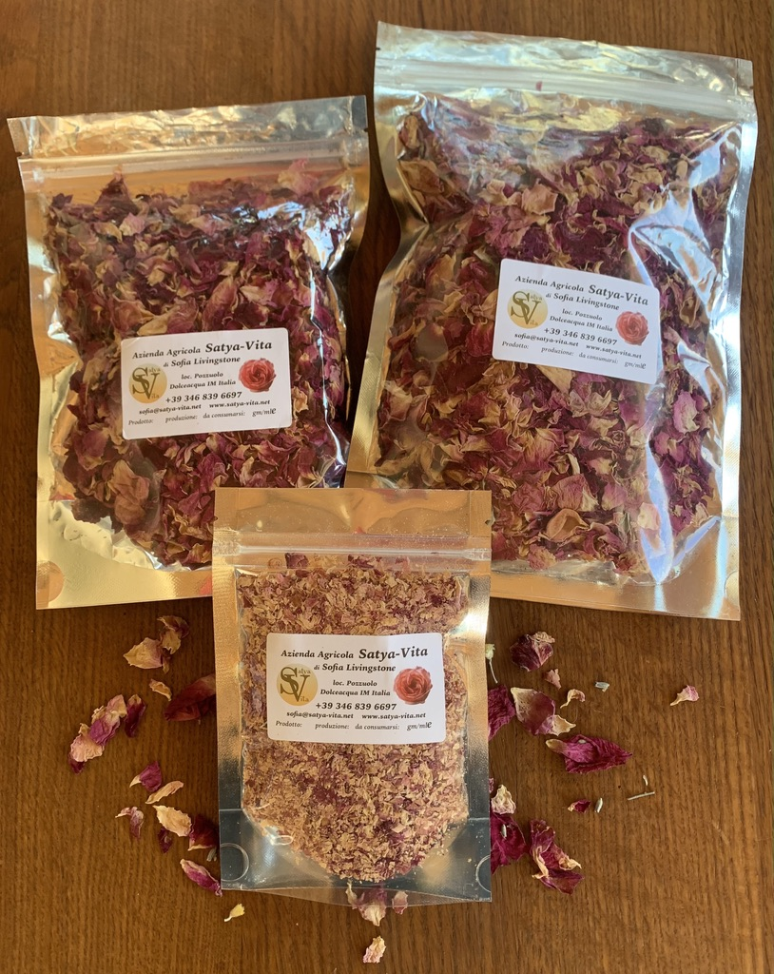~~

Morning's rose pickings……. Dried bags and ground petals

**ROSE PETAL SYRUP** : ~~Easy to make, the concentrate can be drizzled over ice-cream or yoghurt with a few shavings of chocolate for a simple, delicious dessert. It is very special to add to chai tea or simpler still, mix with carbonated or plain water~~.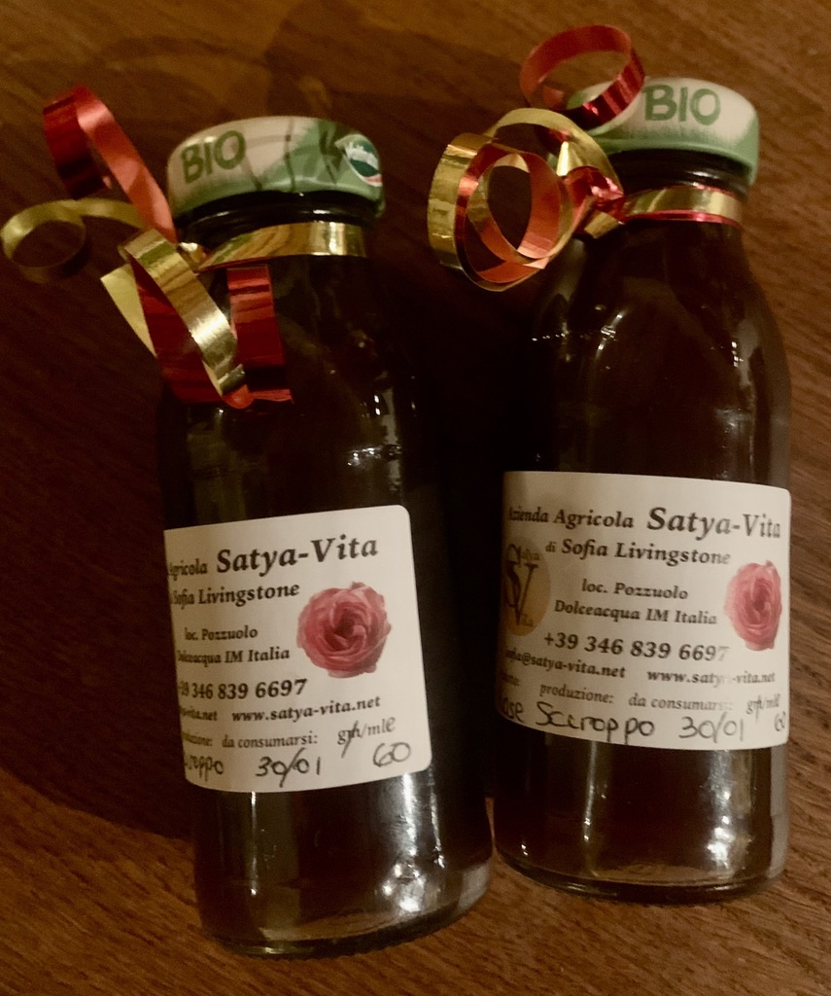

~~INGREDIENTS : ROSE PETALS - One cup, WATER (filtered or distilled) - One Cup, SUGAR - One Cup (white or cane sugar, not honey - depending on flavour preferred). LEMON JUICE - one quarter teaspoon to every cup of petals.~~

~~INSTRUCTIONS - In a bowl, combine sugar and rose petals, mix well and cover with plastic wrap or lid overnight. Move sugar and petals to a saucepan and add filtered or distilled water. Over medium heat, stir well to dissolve sugar…..leave to infuse until cool. Check sugar has melted. Let it sit overnight. Strain off flower petals using muslin or cheesecloth for ease. Transfer to sterilised jars with tight fitting lids. Should last for some weeks in the fridge.~~

**DIVINE CHOCOLATE TRUFFLES :** ~~This is a recipe by Pavla an artist, is delicious, rich and simple to make - with one jar of almond butter from Chicco Cri and two of their coconut cream cans in Dolceacqua, you can make about 110 chocolates and you can freeze them for presents or to eat as treats.~~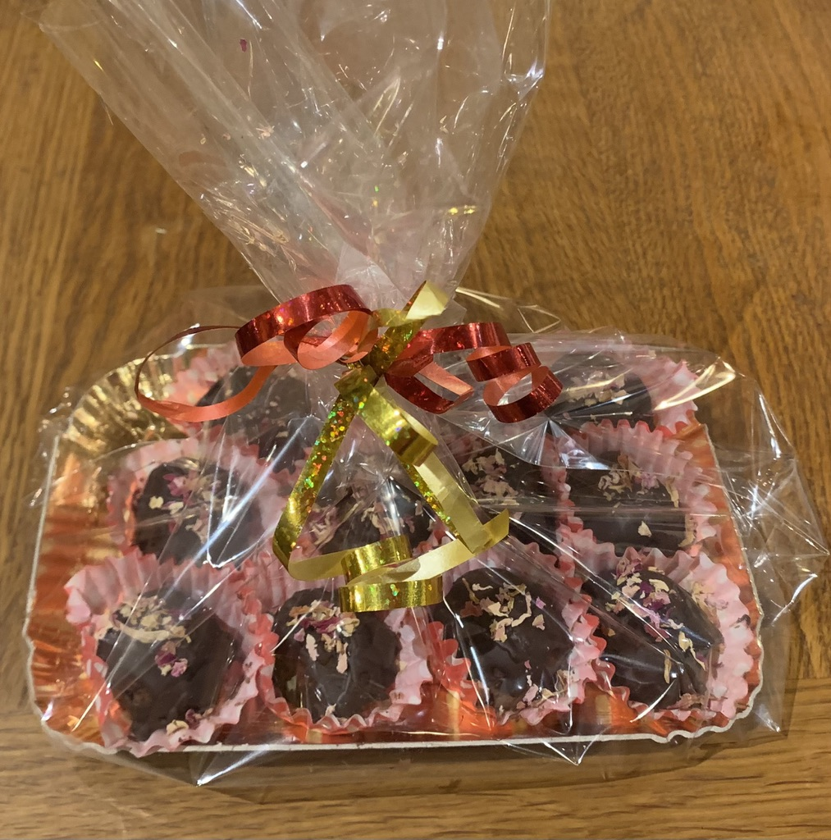

~~INGREDIENTS : For about 55 pieces - I use ice cube trays as this is the simplest way to make them.~~

~~200 g organic dates, 200ml organic coconut cream, 80 g almond tahini or almond butter, 70g dark chocolate with more than 70% (melted in water bath, 70g organic coconut oil, 80ml organic rose water (Satya vita or make yourself from your own roses).~~

~~INSTRUCTIONS : Prepare dates carefully to be 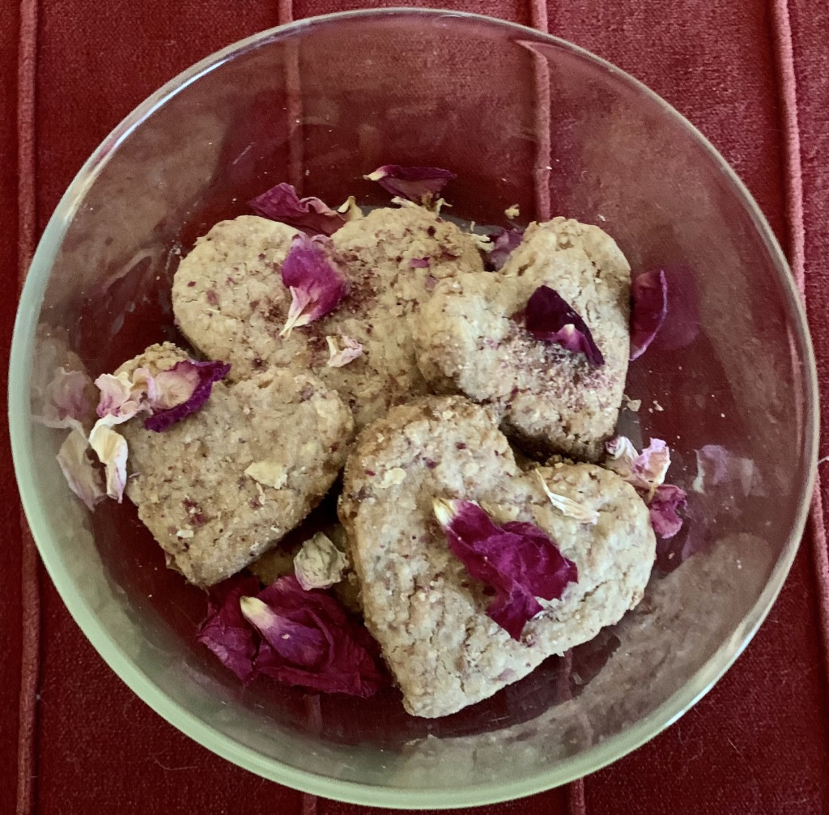without stones while you melt the chocolate in a water bowl. Add all ingredients into blender until smooth (no stones!!), it will make some noise if the dates are hard. Spread into ice cube trays and place in freezer for few hours or more.~~

~~When you are ready and once chocolates are nicely frozen cold, melt another 70g of dark chocolate and using a wooden skewer dip or spread melted chocolate all around. Place in little cups, add a little extra melted chocolate and sprinkle ground rose petals as lovely decoration. Keep in freezer and eat as semi-freddo or leave in warm to go softer as preferred. If you keep in fridge they will last a week, that is if you don't eat them all in one go as they are irresistible.~~

**ROSE AND VANILLA SHORTBREAD** : ~~Delicious gluten free, high protein, low sugar biscuits made with ground dried rose petals~~.

~~INGREDIENTS : One cup Unsalted Butter at room temperature, Half cup Sugar (I use coconut sugar), Half teaspoon salt, 3 tablespoons rose petals (ground dried petals - using coffee grinder), 1 Vanilla bean scraped or good quality vanilla essence, 2 Cups Flour (I use almond and rice to be gluten free and high in protein)~~

~~INSTRUCTIONS : Place butter and sugar in bowl, cream together with electric hand mixer. Add salt, ground rose petals and vanilla, mix and blend. Add flour at low speed. Shape into ball, wrap in plastic wrap and refrigerate for two overs or more.~~

~~Place in preheated oven to 325 degrees F (celsius 160) and use parchment paper. On lightly floured surface, roll dough to thickness as preferred and shaped cutters. Place on baking sheets a little apart, bake for 10-13 minutes until cookies start to brown. Cool completely before storing. Once cool, dust with powdered sugar or sprinkle some ground rose petals~~.

**ROSE LIQUEUR**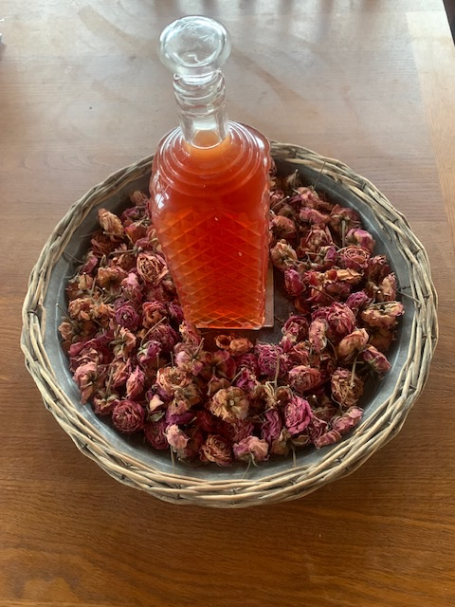

~~INGREDIENTS : 4 Cups of rose petals from highly scented, fragrant roses (unsprayed), 2 Cups very strong soda or grappa, 2 cups sugar (usually white), 2 cups of filtered or distilled water (I also use rose hydrosol here for extra flavour)~~

~~INSTRUCTIONS : Place rose petals in a clean, ideally sterilised jar, add alcohol, close and keep in a cool dark place for at least two weeks. Prepare sugar syrup, boil water and sugar until dissolved, allow to cool. Filter the alcohol mixture and add syrup.~~

~~Keep for at least three months before using. Some recipes the petals are left int he alcohol/syrup mixture and then strained at time of serving.~~

**ROSE ELISIR** (~~or others herbal options like Oregano/Thyme for immune support~~)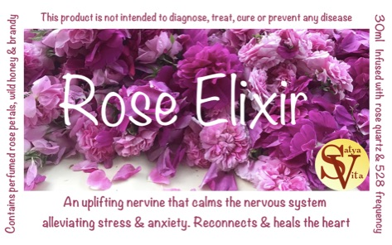

~~Use dried rose petals to increase stability as there is no water content. Ratio is then one part dried petals to five parts alcohol (40% content minimum). Fill jar to half full if using dried, ie less than with fresh.~~

~~INGREDIENTS : Sterilised glass jar, dried or fresh highly perfumed rose petals, not sprayed. Raw local and ethically sourced honey. Alcohol of choice (brandy and bourbon is often used or vodka which is purest and most neutral tasting).~~

~~INSTRUCTIONS : Fill jar with rose petals (full but not packed down too much and less if using dried. Fill jar with about third of the way with honey. Top with alcohol and make sure all petals covered to avoid risk of mould. If using metal lid, use parchment paper between the lid and elixir to prevent contamination,. Minimise the air space between the liquid and parchment to help avoid any rot.~~

~~Allow the jar to sit in a cool and dark place for minimum of at least 4-6 weeks. A few times a week, give it a shake and some love. Use a chopstick or wooden spoon to push down the petals to ensure they are always covered by liquid. When ready, strain out petals or other herbal products (can use a wide variety of plants for different remedies….), using a cheesecloth. Jar up storing away from direct sunlight and heat.~~